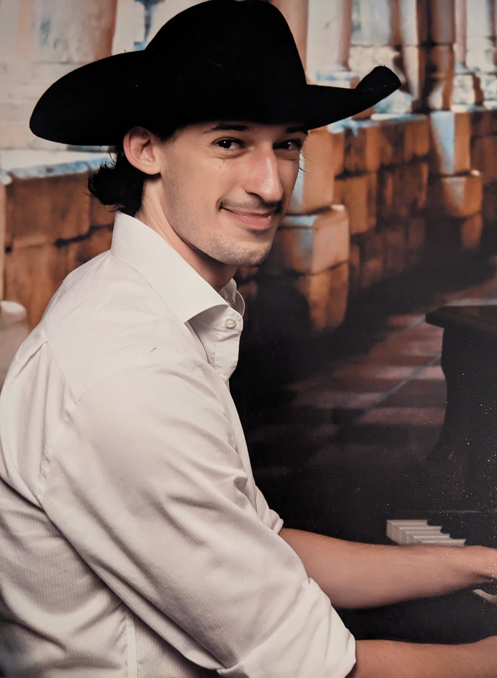

Martin Vershel
he/him/his
Voice: D2 – A4

Email: martin.vershel@gmail.com Phone: (470) 444-9961 Website: www.martinvershel.com
Height: 6’0” Ethnicity: Hispanic Vaccination: Booster (04/01/2022)

Training
Singing: Cobb County Center for Excellence in the Performing Arts (CCCEPA) at Pebblebrook HS – Vocal Major (4 years;
Dr. Katie Woolf, Mr. Frank Timmerman, Mr. John-Michael D’Haviland, Dr. Indra Thomas), Governor’s Honors
Program: Vocal Major (Tom FitzStephens), Mark Christine (College Audition Coach) – 3 years, Various Teachers (TCU) –
1 year
Piano: Daved Palmer (Mastering the Piano) – 3 years, Evelyn White (CCCEPA) – 4 years,
Theory: Ariel Montero (CCCEPA) – 4 years

Performance
Company/Project Position Additional Information
Carnival Cruise Lines Duo – Country Keyboardist/Singer 720 performance hours; 4 hours/day, 6 days/week;
First Contract: 6/22/23 – 9/28/23
Second Contract: 7/4/24 – 10/24/24; 20 original
songs performed
Macy’s Dept. Store Macy’s All-Star Choir – Singer 2 performance hours; televised performance; with
Cee Lo Green

Ashes / Dust (2020) Producer/Singer/Songwriter, Pianist Concept EP, Self-created, published on most major
music platforms

Special Skills: Proficiency
Musical Composition: 8/10
- 20 minutes to complete a song
- Familiarity and fluency in country/folk style of composition and instrumentation
Lyricism: 9/10
- 20 minutes to complete a song
- Natural, evocative lyricism
Piano/Keyboard Sight-reading (Chord Charts): 8/10
- Ability to follow a chord chart (4-5 chords) immediately upon receiving the chart

